Software Quality Assurance (SQA) – 3RD Week Project Task
Name: Dariya Hashmi -- DHC (2403)

Project Title: Automation Testing (Automation Scripts)

Automate at least two test cases:

Login Validation Test :

Objective:
Verify that a user can log in successfully with valid credentials.

Steps (Manual):
- Open the browser and navigate to the login page.
- Enter valid username and password.
- Click on Login button.
- Verify that user is redirected to the secure dashboard page.
- Confirm success message appears.
Valid Login
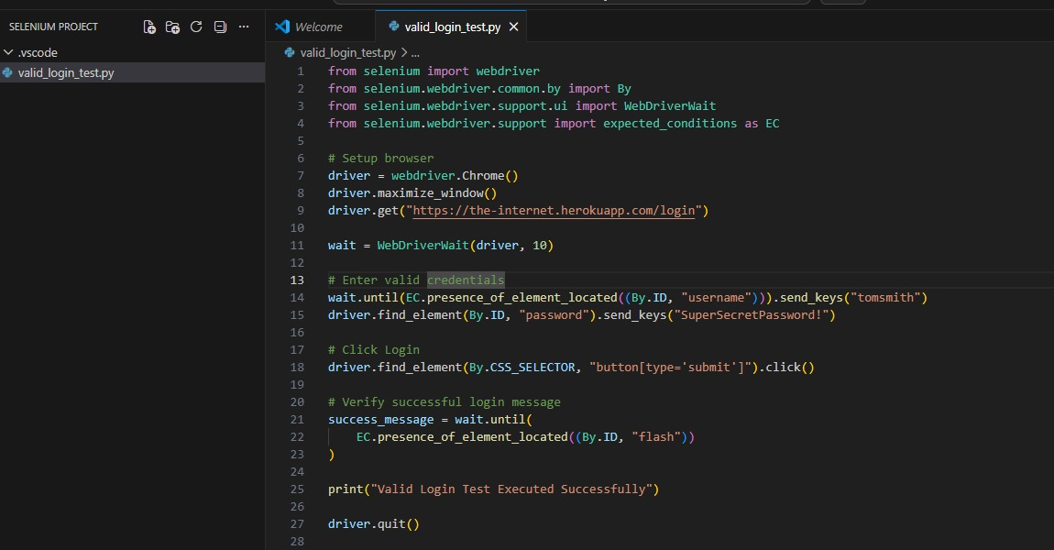
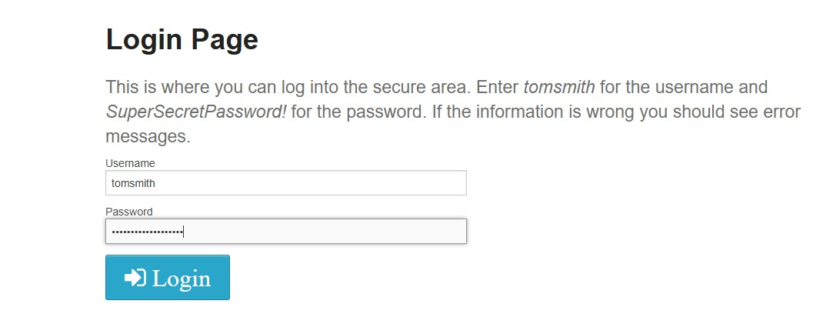
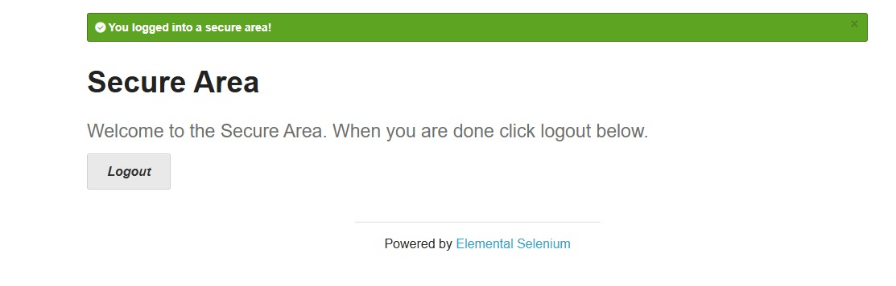
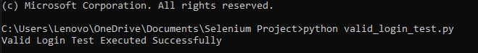

Invalid Login
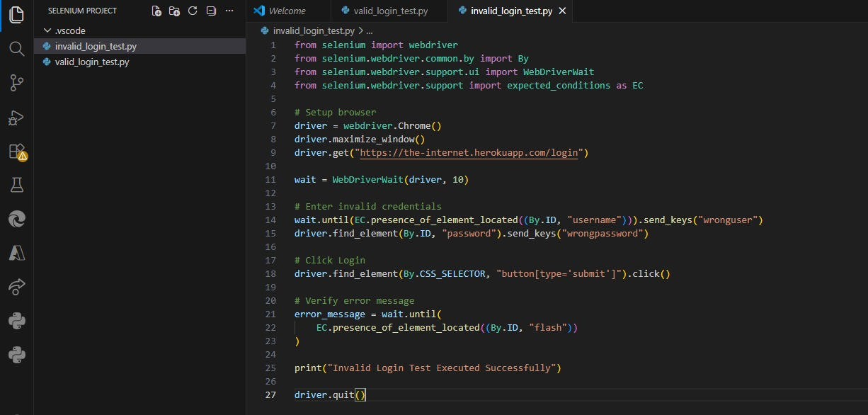
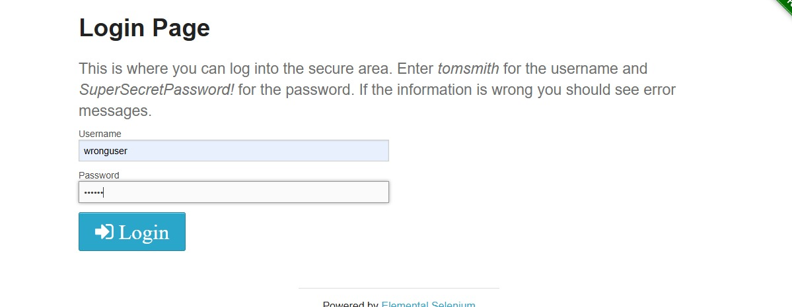
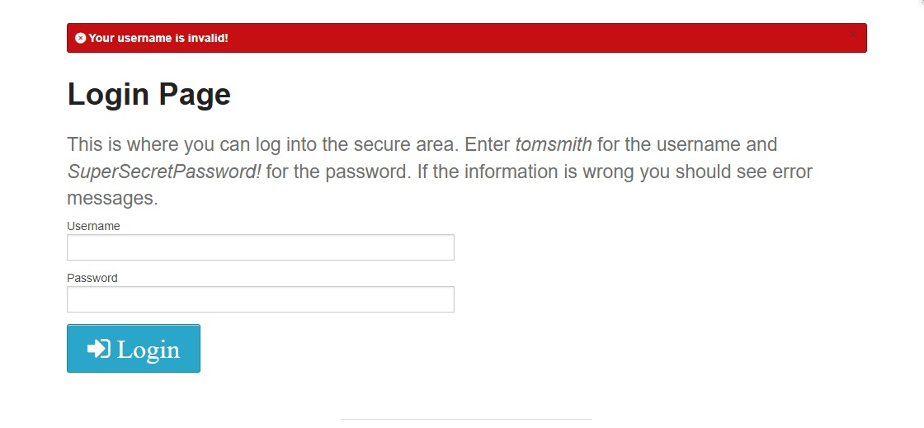

2. Dashboard / Feature Functionality Test (Logout Feature):
After login, user goes to secure dashboard page. We will test the Logout functionality as dashboard feature.

Objective:
Verify that the Logout feature works correctly after successful login.

Steps (Manual):
- Login to the application with valid credentials.
- Navigate to the secure dashboard page.
- Click on Logout button
- Verify that user is redirected back to login page.
- Confirm logout success message appears.

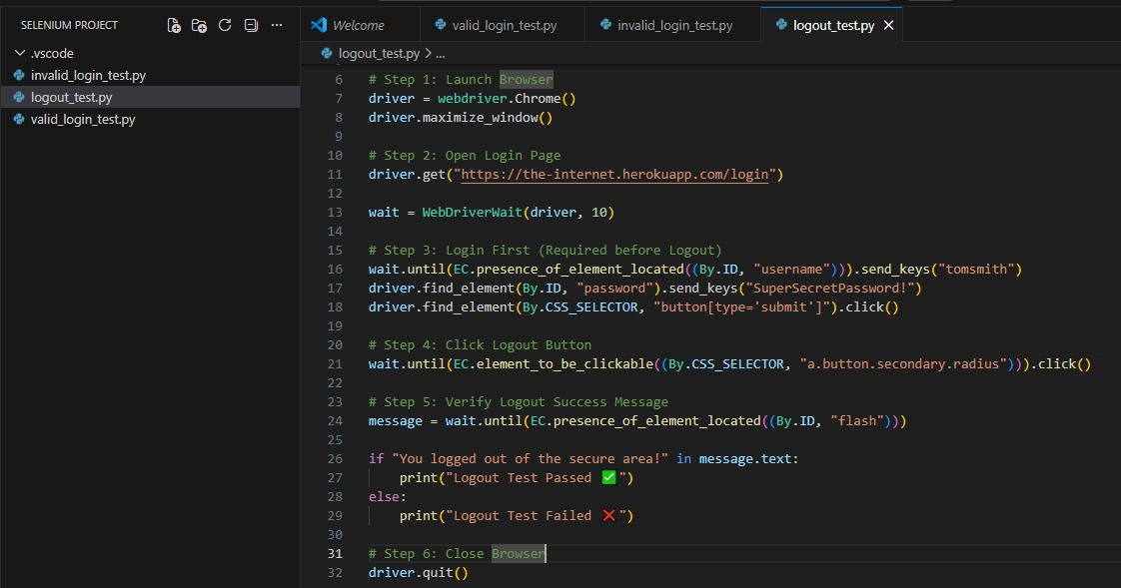
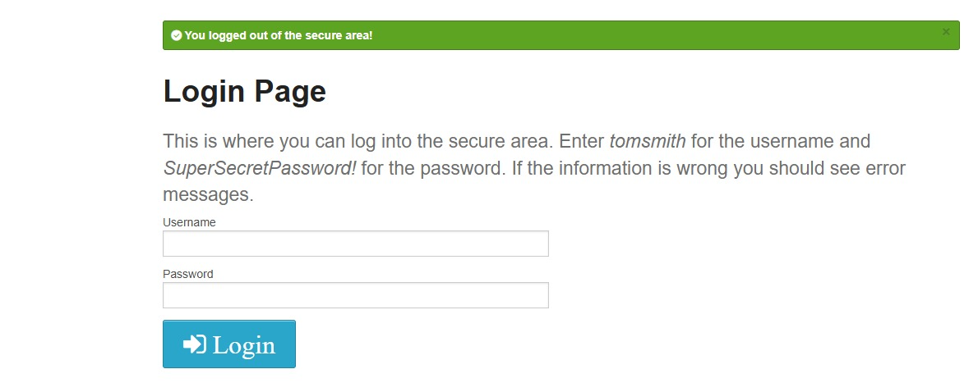
Github repoistry link:
https://github.com/dariyahashmi2602-source/SQA_Week-3_Automation-Scripts

